**FOOD WASTAGE MANAGEMENT SYSTEM**

**Pre requisites**

* JDK1.8
* Apache Tomcat7.0.32
* Mysql
* Bootstrap
* Thymeleaf
* Spring Web
* Spring data jpa dependency

**Installation**

* Open your preferred IDE (Eclipse, SpringToolSuite4) and create spring starter project.
* Change your preference to maven project and java version 8 for spring boot project.
* Select Mysql driver spring boot dev tools, spring data jpa, spring web mvc for web application as dependencies.
* Open your preferred Sql and create database to which the data to be stored.
* Open application property and provide the URL username, password of your mysql database in which your sql data to be stored.

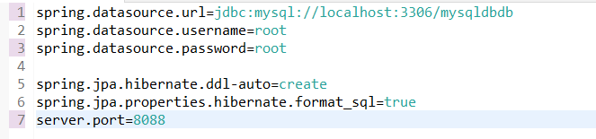

* Now run the project as spring boot application then registration page is opened.
* Credentials for Logging into the website.

Email(register by the user in the registration form)

Password(register by the user in the registration form)